**Web design review**

Web-related technologies:

* Hypertext Markup Language (HTML)
* Cascading Style Sheets (CSS)
* JavaScript and DOM scripting
* Server-side programming and database management

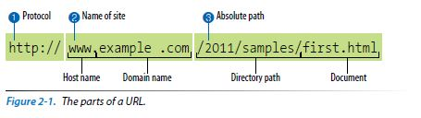

Default files: index.html

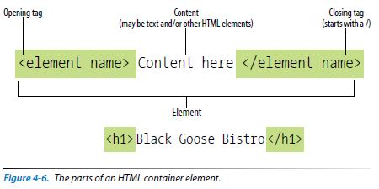

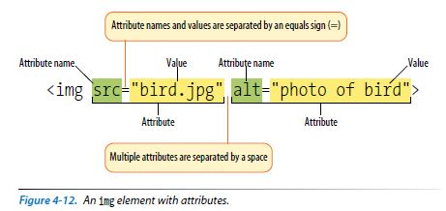

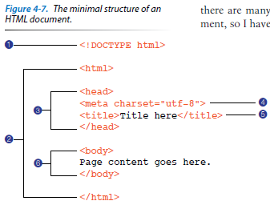

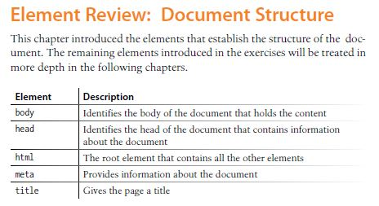

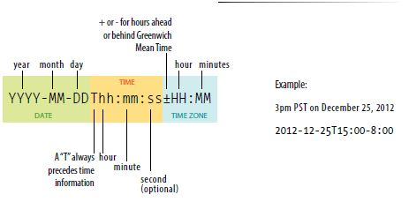

**<div>...</div>**

*Generic block-level element*

<div class="listing">

<img src="felici-cover.gif" alt="">

<p><cite>The Complete Manual of Typography</cite>, James Felici</p>

<p>A combination of type history and examples of good and bad type

design.</p>

</div>

**<span>...</span>**

*Generic inline element*

<ul>

<li>John: <span class="tel">999.8282</span></li>

<li>Paul: <span class="tel">888.4889</span></li>

<li>George: <span class="tel">888.1628</span></li>

<li>Ringo: <span class="tel">999.3220</span></li>

</ul>

**Absolute URLs:** *Example:* href=<http://www.oreilly.com/>

**Relative URLs:** *Example:* href="recipes/index.html"

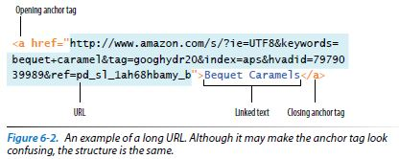

The syntax uses the **tel:** scheme and is very simple.

<a href="tel:+18005551212">Call us free at (800) 555-1212</a>

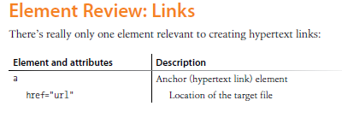

<img src="executivesalaries.png" alt="Executive salaries 1999-2009" longdesc="salaries-ld.html">



<h1>Inline (floating) Frames</h1>

<iframe src="list.html" width="400" height="250">Your browser does not support inline frames. Read the <a href="list.html">list</a>. </iframe>

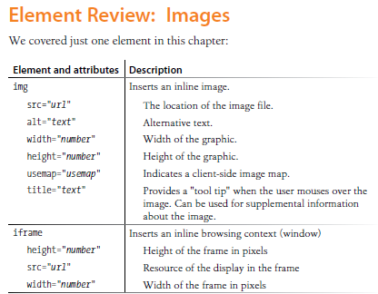

**<table>...</table>**

*Tabular content (rows and columns)*

**<tr>...</tr>**

*Table row*

**<th>...</th>**

*Table header*

**<td>...</td>**

*Table cell data*

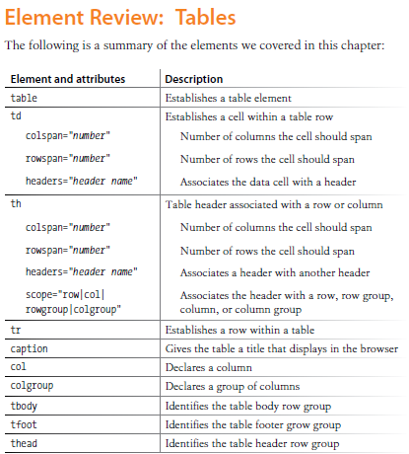

**<input type="search">**

*Search field*

**<input type="email">**

*Email address*

**<input type="tel">**

*Telephone number*

**<input type="url">**

*Location (URL)*

**<input type="submit">**

*Submits the form data to the server*

**<input type="reset">**

*Resets the form controls to their default settings*

**<input type="radio">**

*Radio button*

**<select>...</select>**

*Menu control*

**<option>...</option>**

*An option within a menu*

**<optgroup>...</optgroup>**

*A logical grouping of options within a menu*

**<input type="date">**

*Date input control*

**<input type="time">**

*Time input control*

**<input type="datetime">**

*Date/time control with time zone*

**<input type="datetime-local">**

*Date/time control with no time zone*

**<input type="month">**

*Specifies a month in a year*

**<input type="week">**

*Specifies a particular week in a year*

**<input type="number">**

*Number input*

**<input type="range">**

*Slider input*

**<input type="color">**

*Color picker*

**<progress>…</progress>**

*Indicates the state of an ongoing process*

**<meter>…</meter>**

*Indicates the state of an ongoing process*

<meter min="0" max="100" name="download">50%</meter>

**<output>…</output>**

*Calculated output value*

**<keygen>**

*Key pair generator*

<video src="highlight_reel.mp4" width="640" height="480" poster="highlight_still.jpg" controls autoplay>

</video>

